## AN INTERNSHIP REPORT

**HR Management System Project**

## FOR

**Sunanda Infotech.Pvt.Ltd , Nashik**

## SUBMITTED TO

**SAVITRIBAI PHULE PUNE UNIVERSITY**

## IN PARTIAL FULFILLMENT OF THE REQUIREMENT OF BACHELOR OF ENGINEERING DEGREE(B.E.)

**SUBMITTED BY**

**Aher Aboli Sanjay**

## UNDER THE GUIDANCE OF

**Prof.S.D.Pagar**

## THROUGH

**S.N.J.B’S LATE SAU. K.B.JAIN COLLEGE OF ENGINEERING, NEMINAGAR, TAL. CHANDWAD, DIST. NASHIK, (M.S)**

**ACADEMIC YEAR: 2021-2022**

# 2.ACKNOWLEDGEMENT

I would like to thank the almighty for his constant grace showered on me and his increasing gift of knowledge and strength that has relentlessly prevailed in my life through the entire project work.It was such an honor and privilege for me to collect information for the company and share with the class.

I would have not completed my project without the help and co-operation of certain people. I acknowledge my sincere thanks to Prof.S.D.Pagar Mam guidance that made me materialize this Internship. Finally, I am also thankful to my parents and friends for their encouragement and support. I would like to thank Dr.R.R.Bhandari Sir for the guidance and support they have provided during the Internship.

**Aher Aboli Sanjay**

72189715K

# COLLEGE CERTIFICATE

**INTERNSHIP COMPLETION CERTIFICATE**

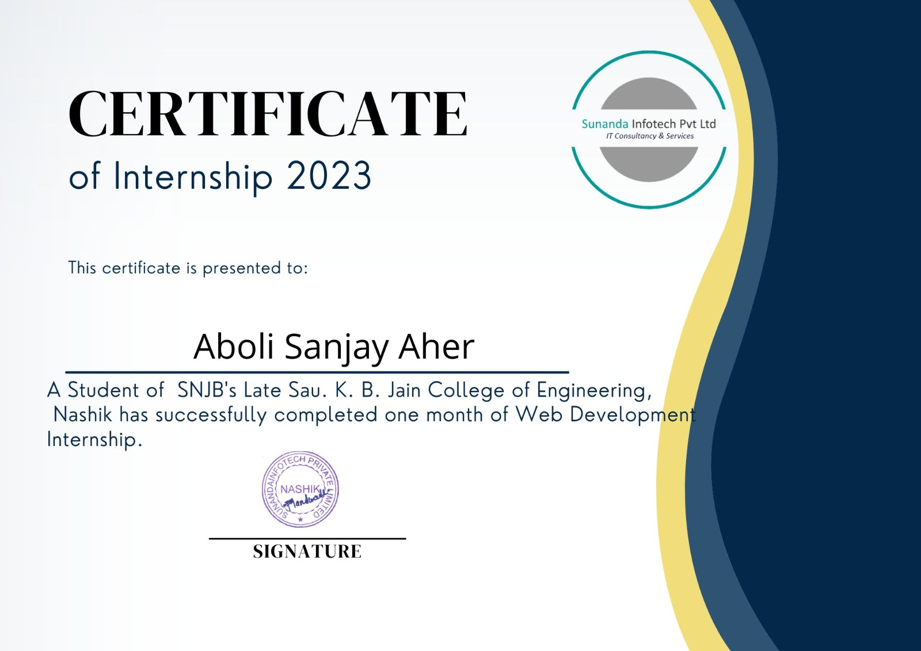

# INTERNSHIP PLACE DETAILS

### Company Profile :

### Name of company: Sunanda Infotech Pvt.Ltd.

### Location/ address/ pin code:  Office No-105, Tirumala Heights, Panchavati, Nashik, Maharashtra 422002, Nashik, Maharashtra 422001.

### Establishment: 2017.

### Email:  sunandainfotech.firm@gmail.com

### Web Address: https: //www.sunandainfotech.com/

### Type of product: Manufacturing industry

### Type of control: Private

### Type of company: Small scale

### They transform Ideas Into Successful Implementations With over 7 years of experience in outsourcing software development. They have 1200 project are completed and 3781customer services.Sunandainfotech.Pvt.Ltd is a leading Information Technology (IT) Service provider in Nashik and Mumbai, who delivers the complete solution for the entire software necessities with the assured quality. We proved our competence in IT consulting, Technology services, R&D and Technology service, IEEE project development, corporate training, Academic Project enhancement, Business Process Outsourcing, Web Designing, Content writing, Research Article submission, Blogger services, and Management solution. To leverage there expertise and skills to get relief

### from their short and long-term software development needs.

Sunandainfotech Private Limited is an unlisted private company incorporated on 18 April, 2017. It is classified as a private limited company and is located in Nashik, Maharashtra. It's authorized share capital is INR 1.00 lac and the total paid-up capital is INR 1.00 lac.

**Description**: This company provides web application designing, mobile application development & pathology lab application services.

**Product and Services** : Web application designing, Mobile application development and pathology lab application.

**Category**: Service Provider

The current status of Sunandainfotech Private Limited is - Active.The last reported AGM (Annual General Meeting) of Sunandainfotech Private Limited, per our records, was held on 29 November, 2021.Sunandainfotech Private Limited has two directors - [Vishal Sudam Mandwade](https://www.tofler.in/vishal-sudam-mandwade/director/07781639) and [Siddharth Sudam Mandwade](https://www.tofler.in/siddharth-sudam-mandwade/director/07781824).The Corporate Identification Number (CIN) of Sunandainfotech Private Limited is U72900MH2017PTC293957. The registered office of Sunandainfotech Private Limited is at R/H 13, SAI SHRIJI R/H, PL-234, SN 491/A, NEAR SHRIRAM NAGAR,, Nashik, Nashik, Maharashtra.

### Vision & Values

The most admired Information Technology Solution Providers globally with leadership focus in delivery of products, solutions and services which are globally competitive.

### The New Generation Of Sunanda Infotech:

* + Delivery of Product and Services which are globally competitive.
  + Continuous improvement of our products, processes and people.
  + Continuous satisfaction of our customers , shareholders and employees.

### Mission

Sunanda Infotech Private Limited. Information Technology will provide products and services that not only meet but exceed the expectation of our customers through planned and continuous improvement of our Services,Products, Processes and People.

The Mission of the Human Resources Department, is to Recruit, Develop and Retain the High-Caliber Diverse workforce

* + Employee centric organization
  + Well defined the processes
  + Long term engagement with multiple project opportunities
  + Diversity in verticals/domain focus – Finance, Telecom, Technology, Shipping, Airlines, Medical….…
  + Well carved learning curve with performance management system
  + Rewards & Recognition
  + Cross training/learning opportunities & redeployment opportunities

### Building Commitment:

* + Focus – Employees are given equal opportunities
  + Involvement – Marching together towards common goal
  + Development – Encourage opportunities for learning and growth
  + Gratitude – Recognize performance (formal or informal)
  + Accountability – Employees are given freedom to work and outshine.

# STUDENT’S DECLARATION

I, the undersigned, hereby declare that, the project entitled, **“HR Management System Project”**is executed as per the course requirement of four year full time B. E. program of Savitribai Phule Pune University. This report has not been submitted by me or any other person to any other University or Institution for a degree or diploma course. This is my own and original work.

**Place: Nashik.**

**Date:**…………………..

**Aher Aboli Sanjay**

**PRN- 72149815K**

# INDEX

|  |  |  |
| --- | --- | --- |
| **Chapter No.** | **Title of Contents** | **Page No** |
|  | Acknowledgement | i |
|  | College Certificate | ii |
|  | Internship Completion Certificate | iii |
|  | Internship Place Details | iv |
|  | Student’s Declaration | v |
| 1 | Introduction |  |
| 2 | Problem Statement /Objectives of the Study or Internship |  |
| 3 | Motivation / Scope of Internship work |  |
| 4 | Methodological details / Live project details |  |
| 5 | Data Analysis and Interpretations of project |  |
| 6 | Result and Learning from Internship |  |
| 7 | Bibliography |  |

**Chapter 1: Introduction**

HTML is very easy to learn and understand. HTML is the first and foremost language that the person will go through for the one who is learning web development. It has simple tags, and there is no hectic case sensitivity in HTML. It simply has some tags that serve a specific purpose, and that’s it. One can easily understand another's code and can make changes in it if required as there is not a lot more to understand in it. Moreover, it does not throw any error or create any problem like other programming languages if the developer forgets to close the tags or make some mistakes in code.

HTML can be easily integrated with multiple languages and does not create any issues in it. For example, in Javascript, Php, node.js, CSS and many more, we write the code of these languages between the HTML, and it mixes with them very easily.

For any online venture to succeed, it must have a website with a great look and features. For that purpose, they have web development teams to take care of the website. This web development domain is growing at a rapid pace. As per research, the employment of web developers and digital designers is expected to grow at an 8 per cent rate from 2019 to 2029, much better than the average of other job profiles.

HTML can be easily integrated with multiple languages and does not create any issues in it. For example, in Javascript, Php, node.js, CSS and many more, we write the code of these languages between the HTML, and it mixes with them very easily.

The simplest website you can make as a beginner is a tribute page of someone you admire in your life. It requires only basic knowledge of HTML and CSS. Make a webpage writing about that person adding his/her image. On the top of the webpage, add the image and name of the person and below that give layout for the rest of the details. You can use paragraphs, lists, links, images with CSS to give it a decent look. Add a suitable background color and font style on your webpage. Most of the parts you can make using HTML but to give it a better look using a bit of CSS. Take help from the link given below.

A landing page is another good project you can make using HTML and CSS but it requires a solid knowledge of these two building blocks. You will be using lots of creativity while making a landing page. You will practice how to add footer and header, create columns, align-items, divide the sections and a lot of things. You will have to use CSS carefully keeping in mind that different elements do not overlap with each other. You will also take care of color combinations, padding, margin, space between sections, paragraphs, and boxes. Color combinations should go well with each other for different sections or backgrounds.

### Solution Approach:

**What is HTML?**

* + - HTML stands for Hyper Text Markup Language
    - HTML is the standard markup language for creating Web pages
    - HTML describes the structure of a Web page
    - HTML consists of a series of elements
    - HTML elements tell the browser how to display the content
    - HTML elements label pieces of content such as "this is a heading", "this is a paragraph", "this is a link", etc.

### FOUR KEY CONCEPTS

The first step toward understanding and working with HTML is learning the basic terms that describe most of the functions of this language. You will come across these terms repeatedly as you use HTML and if you understand them, you will have progressed a long way toward comprehending HTML, not to mention XHTML.

### ELEMENTS

All HTML pages are made up of elements. Think of an element as a container in which a portion of a page is placed. Whatever is contained inside the element will take on the characteristics of that element. For example, to identify a heading on a page, you would enclose it in a heading element <h1>

</h1>. If you want to create a table, you put the table information inside the table element <table>

</table>. To construct a form, you need the form element <form> </form>**.**

### TAGS

Often, you’ll find the terms element and tag used interchangeably. It’s fairly common, but not strictly accurate. An element is made up of two tags: an opening tag and a closing tag. Although it might seem somewhat picky to make this distinction, when you begin to work with XHTML (Extensible Hypertext Markup Language), it will be a very important difference to remember. If you get into the habit of distinguishing elements and tags from the very beginning, you’ll save yourself some confusion down the line.

All tags are constructed the same way. The tag begins with a “less than” sign (<), then the element name, followed by a “greater than” sign (>). For example, an opening tag for the paragraph element would look like this: <p>. The only difference in a closing tag is that the closing tag includes a slash (/) before the element name: </p>. Your content goes between the tags. A simple paragraph might look like this:

<p>This is an HTML paragraph.</p>

Some elements do not use closing tags because they do not enclose content. These are called empty elements. For example, the line break element <br> does not require a closing tag. In the case of empty elements, add a closing slash after the element name, like this: <br />. When a browser sees the slash, it will recognize the element as one that does not need a separate, closing tag.

### ATTRIBUTES AND VALUES

Attributes are another important part of HTML markup. An attribute is used to define the characteristics of an element and is placed inside the element’s opening tag. For example, to specify the size of an image or graphic on your page, you would use the image element <img /> along with the height and width attributes:

<img height=" " width=" " />

Be sure to notice that an equals sign and a set of quotation marks follow both the height and the width attributes. That’s because attributes need values to go with them. In the case of the preceding illustration, you might add a value of 200 to cause your image to display at a size of 200 x 200 pixels:

<img height="200" width="200" />

values work together with attributes to complete the definition of an element’s characteristics. An easy way to think of how attributes and values work together is to compare them with nouns and adjectives. A noun names something; an adjective describes it. An attribute names a characteristic; a value

describes it. Imagine that you are trying to identify a person’s hair color with a markup language. Hair would be the element, color the attribute, and red the value. You might write such a description as follows:

<hair color="red">Red-headed Person</hair>

### NESTING

Often you will want to apply more than one element to a portion of your page. An essential concept to understand is nesting. Nesting simply means that elements must never overlap. Properly nested elements are contained inside one another, as in the following:

### <a> <b> <c> </c> </b> </a>

Sometimes it’s easier to understand the concept if the elements are displayed vertically, like this:

### <a><b><C>

**</c>**

### </b>

**</a>**

### The following elements, on the other hand, are overlapping:

**<a>**

### <b>

**</a>**

### <c>

**</b>**

### </c>

Web browsers displaying an HTML page can be pretty forgiving if your elements are not properly nested; however, overlapped elements can create garbled results, particularly if you are trying to construct frames or tables. Also, when you become familiar with XHTML's stricter standards, you’ll discover that overlapping elements are an absolute “no-no.”

### What is CSS?

* + - CSS stands for Cascading Style Sheets
    - CSS describes how HTML elements are to be displayed on screen, paper, or in other media
    - CSS saves a lot of work. It can control the layout of multiple web pages all at once
    - External stylesheets are stored in CSS files

### What is JSP?

* It stands for **Java Server Pages**.
* It is a server side technology.
* It is used for creating web application.
* It is used to create dynamic web content.
* In this JSP tags are used to insert JAVA code into HTML pages.
* It is an advanced version of Servlet Technology.
* It is a Web based technology helps us to create dynamic and platform-independent web pages.
* In this, Java code can be inserted in HTML/ XML pages or both.
* JSP is first converted into servlet by JSP container before processing the client’s request.

**JSP pages are more advantageous than Servlet:**

* They are easy to maintain.
* No recompilation or redeployment is required.
* JSP has access to entire API of JAVA .
* JSP are extended version of Servlet.

**Features of JSP**

* **Coding in JSP is easy** :- As it is just adding JAVA code to HTML/XML.
* **Reduction in the length of Code** :- In JSP we use action tags, custom tags etc.
* **Connection to Database is easier** :-It is easier to connect website to database and allows to read or write data easily to the database.
* **Make Interactive websites** :- In this we can create dynamic web pages which helps user to interact in real time environment.
* **Portable, Powerful, flexible and easy to maintain** :- as these are browser and server independent.
* **No Redeployment and No Re-Compilation** :- It is dynamic, secure and platform independent so no need to re-compilation.
* **Extension to Servlet** :- as it has all features of servlets, implicit objects and custom tags
  1. **Declaration Tag**:-It is used to declare variables.
  2. **Java Scriplets**:- It allows us to add any number of JAVA code, variables and expressions.
  3. **JSP Expression**:- It evaluates and convert the expression to a string.
  4. **JAVA Comments**:- It contains the text that is added for information which has to be ignored.
     + Create html page from where request will be sent to server eg try.html.
     + To handle to request of user next is to create .jsp file Eg. new.jsp
     + Create project folder structure.
     + Create XML file eg my.xml.
     + Create WAR file.
     + Start Tomcat
     + Run Application
  5. It does not require advanced knowledge of JAVA
  6. It is capable of handling exceptions
  7. Easy to use and learn
  8. It contains tags which are easy to use and understand
  9. Implicit objects are there which reduces the length of code
  10. It is suitable for both JAVA and non JAVA programmer
  11. Difficult to debug for errors.
  12. First time access leads to wastage of time
  13. It’s output is HTML which lacks features.

### Company Introduction:

### Sunandainfotech Private Limited is a leading Information Technology (IT) Service provider in Nashik and Mumbai, who delivers the complete solution for the entire software necessities with the assured quality. We proved our competence in IT consulting, Technology services, R&D and Technology service, IEEE project development, corporate training, Academic Project enhancement, Business Process Outsourcing, Web Designing, Content writing, Research Article submission, Blogger services, and Management solution. This company provides web application designing, mobile application development & pathology lab application services *.*

# Chapter 2: Problem Statement /Objectives of the Internship

### Problem Statement:

### The web-based HR management system is a software application designed to manage and automate various HR processes within an organization. The system is accessed through a web browser and can be used to manage employee data, track time and attendance, process payroll, handle benefits administration, and manage recruitment and training.

### The web-based HR management system aims to improve the efficiency and effectiveness of HR processes by providing access to HR-related tasks and data from any location with an internet connection. The system can also help to ensure compliance with legal and regulatory requirements, as well as improve communication and collaboration among HR staff and other departments within the organization.

### One of the key features of the web-based HR management system is the employee self-service portal, which allows employees to view and update their personal information, request time off, access pay stubs and other HR-related information. This helps to reduce the administrative burden on HR staff and enables employees to manage their own HR-related tasks.

### Another important feature of the web-based HR management system is the reporting and analytics module, which provides HR staff with valuable insights into key HR metrics such as employee turnover, recruitment metrics, and performance metrics. This information can be used to identify trends, make data-driven decisions, and improve HR processes.

### The web-based HR management system also provides the flexibility to scale and adapt to changing business needs. The system can be customized to meet the specific needs of the organization and can be easily integrated with other software applications.

### Overall, the web-based HR management system is an essential tool for any organization looking to streamline and optimize their HR processes, improve compliance and reduce administrative costs, and ultimately, improve employee satisfaction and retention in a convenient and accessible way.

### Project Outcome:

1. Creation of web pages based on a set of inputs.
2. To ensure device compatibility for the web pages.

### Hands-on Details:

The hands on environments or software required to implement the project are:

1. MS Office
2. HTML/CSS/JSP
3. Notepad++

**Primary /Main objectives of internship:**

* To expose to a particular job and a profession or **i**ndustry
* To provide opportunity to develop skills in the field of interest
* Assist in gaining vital work related experience and building strong resume for bright career
* To help in developing business contacts i.e. creating network contacts
* To help potentially land permanent or contractual jobs from host company

**Secondary objectives of internship:**

* To encourage and provide opportunities to get professional or personal experience through internships.
* To learn and understand real life or industrial situations.
* To get familiar with various tools and technologies used in industries and their applications and nurture professional and societal ethics.
* To create awareness of social, economic and administrative considerations in the working environment of industry organizations.

# Chapter 3: Motivation / Scope of Internship work

## Motivation Behind Joining the Internship:

My Motivation to do internship in Sunandainfotech Private Limited was as follows:

1. Sunandainfotech Private Limited is a global IT Service Provide

2. Sunandainfotech Private Limited, The current status of Sunandainfotech Private Limited is - Active.The last reported AGM (Annual General Meeting) of Sunandainfotech Private Limited, per our records, was held on 29 November, 2021.

## Company Profile and Technology:



Sunandainfotech Private Limited is an unlisted private company incorporated on 18 April, 2017. It is classified as a private limited company and is located in Nashik, Maharashtra. It's authorized share capital is INR 1.00 lac and the total paid-up capital is INR 1.00 lac.

This company provides web application designing, mobile application development & pathology lab application services. Product and Servicesweb application designing, mobile application development & pathology lab application.

Category is Service Provider. The current status of Sunandainfotech Private Limited is - Active.

The last reported AGM (Annual General Meeting) of Sunandainfotech Private Limited, per our records, was held on 29 November, 2021.

Sunandainfotech Private Limited has two directors - [Vishal Sudam Mandwade](https://www.tofler.in/vishal-sudam-mandwade/director/07781639) and [Siddharth Sudam Mandwade](https://www.tofler.in/siddharth-sudam-mandwade/director/07781824).

### Services:

1. E-Commerce
2. Web UI Design Kit
3. Mobile Optimization
4. Digital Design for Mac
5. Enterprise Applications
6. Cloud
7. Consulting
8. Data Management Services
9. Website Development Services

### Products:

1. Mobile Application Development
2. Pathology Lab Application
3. Web Application Designing
4. Application Development
5. Desktop Application Development

### Scope of Technology in Market:

The scope of technology in the market for web-based HR management systems is quite promising. As more and more companies move towards digital transformation, the demand for cloud-based HR systems is increasing. The web-based HR management system allows companies to manage their human resource functions more effectively and efficiently, from anywhere at any time.

With the use of advanced technologies like artificial intelligence and machine learning, web-based HR systems can help organizations automate routine HR tasks, streamline processes, and provide real-time insights into employee data. This can help companies to make better decisions, improve employee engagement, and enhance overall organizational performance.

In addition, web-based HR systems can provide better security and data privacy compared to traditional HR systems. The data can be securely stored in the cloud and access can be granted only to authorized personnel.

* + Manufacturing
  + Retail
  + Supply Chain
  + Professionals

Even software development, mobile app development, and digital marketing companies have their own websites obviously.

You can opt to do either a long-term or short-term web development course, and you can find work as any of the following:

* + Web App Developer
  + UI Designer
  + Front-end or Backend Developer
  + UX Architect
  + UX Designer
  + Web Marketing Analyst

You can either be part of a software company or freelance. There is immense scope for either. A freelancer is not likely to have a fixed income, but more freedom; you can pick and choose your projects. A fresh recruit is likely to earn Rs. 1,25,000 per annum, whereas an experienced developer can earn up to 6 or 7 times more.

### Is Web Development a Good Career?

Web development can be an excellent, lucrative career, if you are passionate about developing websites, web apps, or doing UI/UX work. However, you need to frequently upgrade your skills as it is a continuously evolving field.

Webandcrafts is one of the leading website development companies in Kerala, India. Our services include eCommerce development, website designing, mobile application development, digital marketing, etc. We are

committed to providing the best services to our customers meeting industrial and business standards. If you have any queries on eCommerce development, contact us right away.

### Scope of Project in Market:

The scope of a web-based HR management system is broad, as it can be used by organizations of all sizes and across different industries. With the increasing adoption of technology in business operations, there is a growing demand for digital tools that can help streamline HR processes and improve overall efficiency.

Some of the potential market opportunities for a web-based HR management system include:

* Small and Medium-Sized Businesses (SMBs): Many SMBs still rely on manual HR processes or outdated software systems, making them prime candidates for a modern web-based HR management system that can help automate tasks such as onboarding, performance management, and employee records management.
* Enterprises: Large organizations can benefit from a web-based HR management system that can help centralize HR data, provide real-time insights, and automate time-consuming tasks. These systems can help HR teams manage a large workforce and ensure compliance with regulations.
* Global Companies: With a web-based HR management system, global companies can manage HR processes across multiple countries, currencies, and languages. The system can provide a unified view of HR data, while also complying with local regulations and requirements.
* Service Providers: HR service providers can offer a web-based HR management system as a value-added service to their clients, helping them manage HR processes more efficiently and effectively.

# Chapter 4: Methodological details / Live project details

### HTML:

The **HyperText Markup Language** or **HTML** is the standard markup language for documents designed to be displayed in a web browser. It can be assisted by technologies such as Cascading Style Sheets (CSS) and scripting languages such as JavaScript.

Web browsers receive HTML documents from a web server or from local storage and render the documents into multimedia web pages. HTML describes the structure of a web page semantically and originally included cues for the appearance of the document.

HTML elements are the building blocks of HTML pages. With HTML constructs, images and other objects such as interactive forms may be embedded into the rendered page. HTML provides a means to create structured documents by denoting structural semantics for text such as headings, paragraphs, lists, links, quotes and other items. HTML elements are delineated by *tags*, written using angle brackets. Tags such as <**img** /> and <**input** /> directly introduce content into the page. Other tags such as <**p**> surround and provide information about document text and may include other tags as sub-elements. Browsers do not display the HTML tags but use them to interpret the content of the page.

HTML can embed programs written in a scripting language such as JavaScript, which affects the behavior and content of web pages. Inclusion of CSS defines the look and layout of content. The World Wide Web Consortium (W3C), former maintainer of the HTML and current maintainer of the CSS standards, has encouraged the use of CSS over explicit presentational HTML since 1997.A form of HTML, known as HTML5, is used to display video and audio, primarily using the <**canvas**> element, in collaboration with javascript.

**Hypertext markup language (HTML)** is a Hypertext markup language, the standard markup language for documents designed to displayed and viewed on the online during a browser also helps to create the structure of the web page. because it is a markup language, it consists of many tags. There are tags to display text, tables, ordered lists and unordered lists, etc. There are two main sections on the HTML page: head and body section. The data that describes the page also termed as metadata is inside the head section while the body section includes all the tags that are necessary to represent the visible content of the web page HTML is a platform-independent language so that can be made in use in any platform like Windows, Linux, Macintosh, etc.

There are various HTML versions. The newest version is HTML 5. it’s more advanced features like Geo-location, native audio, and video support, Canvas, web socket, etc. Usually, HTML is a simple language to find out and use. A programmer can create an HTML file employing a simple text editor and execute it employing a browser.

### Advantages of HTML:

1. HTML is widely used.
2. Every browser supports HTML Language.
3. Easy to learn and use.
4. HTML is lightweight and fast to load.
5. Do not get to purchase any extra software because it’s by default in every window.
6. Easy to use
7. Loose syntax (although, being too flexible won’t suit standards).
8. HTML is easy enough to write
9. HTML is that it is easy to code even for novice programmers.
10. HTML also allows the utilization of templates, which makes designing a webpage easy.
11. Very useful for beginners in the web designing field.
12. HTML can be supported to each and every browser, if not supported to all the browsers.
13. HTML is built on almost every website, if not all websites.
14. HTML is increasingly used for data storage like XML syntax.
15. Free – You need not buy any software.
16. HTML is present in every window by default so you do not need to buy the software which costs too much.
17. HTML has many tags and attributes which can short your line of code.

### Disadvantages of HTML:

1. It cannot produce dynamic output alone, since it’s a static language.
2. Making the structure of HTML documents becomes tough to understand.
3. Errors can be costly.
4. It is as time consuming as the time it consumes to maintain the color scheme of a page and to make lists, tables and forms.
5. It can create only static and plain pages so if we’d like dynamic pages then HTML isn’t useful.
6. Required to write a lot of code for just creating a simple webpage.
7. We have to check up the deprecated tags and confirm not to use them to appear because another language that works with HTML has replaced the first work of the tag, and hence the opposite language needs to be understood and learned.
8. Security features offered by HTML are limited.
9. If we need to write down long code for creating a webpage then it produces some complexity.
10. HTML can create only static and plain pages so if we’d like dynamic pages then HTML isn’t useful.
11. I need to write down tons of code for creating an easy webpage.
12. Security features are not good at HTML.
13. If we’d like to write down long code for creating a webpage then it produces some complexity.

### CSS:

**Cascading Style Sheets** (**CSS**) is a style sheet language used for describing the presentation of a document written in a markup language such as HTML.CSS is a cornerstone technology of the World Wide Web, alongside HTML and JavaScript.

CSS is designed to enable the separation of presentation and content, including layout, colors, and fonts.This separation can improve content accessibility; provide more flexibility and control in the specification of

presentation characteristics; enable multiple web pages to share formatting by specifying the relevant CSS in a separate .css file, which reduces complexity and repetition in the structural content; and enable the .css file to be cached to improve the page load speed between the pages that share the file and its formatting.

Separation of formatting and content also makes it possible to present the same markup page in different styles for different rendering methods, such as on-screen, in print, by voice (via speech-based browser or screen reader), and on Braille-based tactile devices. CSS also has rules for alternate formatting if the content is accessed on a mobile device.

The name *cascading* comes from the specified priority scheme to determine which style rule applies if more than one rule matches a particular element. This cascading priority scheme is predictable.

The CSS specifications are maintained by the World Wide Web Consortium (W3C). Internet media type (MIME type) text/css is registered for use with CSS by RFC 2318 (March 1998). The W3C operates a free CSS validation service for CSS documents.

In addition to HTML, other markup languages support the use of CSS including XHTML, plain XML, SVG, and XUL.

CSS is defined as a method sheet language that provides web designers control over how an internet site communicates with web browsers including the formatting and display of their HTML documents.

CSS or cascading sheet may be a text-based coding language that specifies the website formats and the way a site communicates with web browsers. The language allows web developers to regulate various style elements and functionalities, like layout, color, fonts, and therefore the formatting and display of HTML documents.

The main goal (as a method sheet language) was to separate document content from document presentation, which incorporates style elements, like color, layout, and fonts. CSS handles the design and feels a part of an internet page. Using CSS, you will control the color of the text, the design of fonts, the spacing between paragraphs, how columns are sized and laid out, etc.

CSS instructs the display of the HTML on how the web site will display at the user’s end. Let us have a glance on the benefits and drawbacks of CSS.

### Advantages of CSS:

1. CSS plays an important role, by using CSS you simply got to specify a repeated style for an element once & use it multiple times because CSS will automatically apply the required styles.
2. The main advantage of CSS is that style is applied consistently across a variety of sites. One instruction can control several areas which is advantageous.
3. Web designers need to use a few lines of programming for every page improving site speed.
4. Cascading not only simplifies website development, but also simplifies maintenance as a change of one line of code affects the whole web site and maintenance time.
5. It is less complex therefore the effort is significantly reduced.
6. It helps to form spontaneous and consistent changes.
7. CSS changes are device friendly. With people employing a variety of smart devices to access websites over the web, there’s a requirement for responsive web design.
8. It has the power for re-positioning. It helps us to determine the changes within the position of web elements who are there on the page.
9. These bandwidth savings are substantial figures of insignificant tags that are indistinct from a mess of pages.
10. Easy for the user to customize the online page
11. It reduces the file transfer size.

### Disadvantages of CSS:

1. CSS, CSS 1 up to CSS3, result in creating confusion among web browsers. With CSS, what works with one browser might not always work with another. The web developers need to test for compatibility, running the program across multiple browsers.
2. There exists a scarcity of security.
3. After making the changes we need to confirm the compatibility if they appear. The similar change affects all the browsers.
4. The programming language world is complicated for non-developers and beginners. Different levels of CSS

i.e. CSS, CSS 2, CSS 3 are often quite confusing.

1. Browser compatibility (some styles sheets are supported and some are not). CSS works differently on different browsers. IE and Opera support CSS with different logic.
2. There might be cross-browser issues while using CSS.
3. There are multiple levels which creates confusion for non-developers and beginners.

### JSP:

### Java Server Pages (JSP) is a technology that enables web developers to create dynamic, server-side web pages. It is a popular alternative to other web technologies like PHP, ASP, and ColdFusion.

### JSP pages are essentially HTML pages that include special tags, known as JSP tags. These tags enable the integration of Java code and provide dynamic content on web pages. The JSP code runs on the server-side and generates HTML or XML output, which is then sent to the client's web browser.

### The JSP technology simplifies web development by allowing developers to separate the presentation layer (HTML, CSS) from the business logic layer (Java code). This separation of concerns enables developers to focus on their respective areas of expertise, leading to efficient and scalable web application development.

### Some of the key features of JSP technology are:

### Easy Integration with Java: JSP pages are built using Java Servlets, which makes it easy to integrate Java code and use Java libraries.

### Platform Independence: JSP technology is platform-independent and can run on any operating system that supports Java.

### Extensibility: JSP technology supports the use of custom tags, which can be used to create reusable components and simplify complex logic.

### Scalability: JSP technology can be used to build scalable web applications that can handle a large number of concurrent users.

### Security: JSP technology provides security features such as SSL support, authentication, and authorization.

### Overall, JSP technology is a powerful tool for building dynamic, server-side web pages using Java. With its ease of use, platform independence, extensibility, scalability, and security features, it is an ideal choice for web developers looking to create modern, data-driven web applications.

### Advantages of JSP:

### There are several advantages of using Java Server Pages (JSP) for web development:

### Easy to Learn: JSP technology is built on Java, which is a popular and widely used programming language. This makes it easy for Java developers to learn and use JSP technology.

### Platform Independence: JSP technology is platform-independent, which means that it can run on any operating system that supports Java. This makes it easy to deploy and maintain JSP-based web applications across different platforms.

### Integration with Java: JSP technology can easily integrate Java code, which makes it easier for developers to use Java libraries and frameworks.

### Separation of Concerns: JSP technology enables developers to separate the presentation layer (HTML, CSS) from the business logic layer (Java code). This separation of concerns makes it easier to maintain and update web applications.

### Reusability: JSP technology supports the use of custom tags, which can be used to create reusable components and simplify complex logic. This makes it easier to develop and maintain web applications.

### Scalability: JSP technology can be used to build scalable web applications that can handle a large number of concurrent users.

### Security: JSP technology provides security features such as SSL support, authentication, and authorization.

### Disadvantages of JSP:

### While there are many advantages to using Java Server Pages (JSP), there are also some disadvantages to consider:

### Steep Learning Curve: Although JSP is built on Java, it requires developers to have a good understanding of both HTML and Java, which can make the learning curve steeper than other web development frameworks.

### Mixing Logic with Presentation: While JSP provides a way to separate the presentation layer from the business logic layer, it can be tempting for developers to mix the two together, which can make the code more difficult to maintain over time.

### Performance Issues: JSP technology relies on server-side processing, which can impact the performance of the web application, especially when handling large volumes of traffic.

### Limited Portability: JSP code is not portable across different web servers, which can make it difficult to move applications from one server to another.

### Security Risks: JSP technology is vulnerable to security risks such as SQL injection attacks, cross-site scripting (XSS) attacks, and others, which can compromise the security of the web application and user data.

### Market Share of HTML:

HTML is used by **94.5%** of all the websites. HTML5 is used by 90.6% of all the websites.

### Different languages and databases in your project:

1. HTML
2. CSS
3. JSP

### Code:

<%@page contentType="text/html" pageEncoding="UTF-8"%>

<!DOCTYPE html>

<html>

<head>

<meta http-equiv="Content-Type" content="text/html; charset=UTF-8">

<title>JSP Page</title>

</head>

<body>

<center>

<form action="register" method="POST" >

<center> Name: <input type="text" placeholder="enter a full name" name="fname" ></center><br>

<center>Username: <input type="text" placeholder="enter a username" name="username" ></center><br>

<center>Password: <input type="text" placeholder="enter a Password" name="password" ></center><br>

<center>EmailID: <input type="text" placeholder="enter a email ID" name="emailid" ></center><br>

<center>Mobile no: <input type="text" placeholder="enter a Mobile number" name="mobileno" ></center><br>

<center>Address: <input type="text" placeholder="enter a Address" name="address" ></center><br>

<center> <input type="submit" value="submit" name="type"></center> <br>

</form>

</center>

</body>

</html>

<%@page import="java.sql.ResultSet"%>

<%@page import="com.db.DBConn"%>

<%@page import="java.sql.Statement"%>

<%@page contentType="text/html" pageEncoding="UTF-8"%>

<!DOCTYPE html>

<html>

<head>

<meta http-equiv="Content-Type" content="text/html; charset=UTF-8">

<title>JSP Page</title>

</head>

<body>

<table border="1" cellpadding="5">

<caption><h2>TABLE</h2></caption>

<tr>

<td>id</td>

<td>fname</td>

<td> username</td>

<td> password</td>

<td> emailid</td>

<td> mobileno</td>

<td> address</td>

</tr>

<%

Statement st = DBConn.connect();

String query ="SELECT * FROM `register`";

ResultSet rs = st.executeQuery(query);

while(rs.next()){

%>

<tr>

<td><%=rs.getString("id")%></td>

<td><%=rs.getString("fname")%></td>

<td><%=rs.getString("username")%></td>

<td> <%=rs.getString("password")%></td>

<td> <%=rs.getString("emailid")%></td>

<td> <%=rs.getString("mobileno")%></td>

<td> <%=rs.getString("address")%></td>

<td><a href="delete.jsp?id=<%=rs.getString("id")%>">Delete </a></td>

<td><a href="edit.jsp?id=<%=rs.getString("id")%>">Edit </a></td>

</tr>

<%

}

%>

</table>

</body>

</html>

<%@page import="java.sql.Statement"%>

<%

String id= request.getParameter("id");

String query="DELETE FROM `register` WHERE id="+id+"";

Statement st = com.db.DBConn.connect();

st.executeUpdate(query);

response.sendRedirect("table.jsp");

%>

<<%@page import="java.sql.ResultSet"%>

<%@page import="java.sql.Statement"%>

<%@page contentType="text/html" pageEncoding="UTF-8"%>

<!DOCTYPE html>

<%

String id=request.getParameter("id");

Statement st=com.db.DBConn.connect();

String query="SELECT * FROM `register` WHERE id="+id+"";

ResultSet rs = st.executeQuery(query);

while(rs.next())

{

%>

<form action="register" method="POST" >

<tr>

Id: <input type="text" placeholder="enter id" name="id">

Name: <input type="text" placeholder="enter a full name" name="fname" >

username: <input type="text" placeholder="enter a username" name="username" >

center>Password: <input type="text" placeholder="enter a Password" name="password" ></center><br>

<center>EmailID: <input type="text" placeholder="enter a email ID" name="emailid" ></center><br>

<center>Mobile no: <input type="text" placeholder="enter a Mobile number" name="mobileno" ></center><br>

<center>Address: <input type="text" placeholder="enter a Address" name="address" ></center><br>

<center> <input type="submit" value="submit" name="type"></center> <br>

</tr>

</form>

}

<%@page contentType="text/html" pageEncoding="UTF-8"%>

<!DOCTYPE html>

<html>

<head>

<meta http-equiv="Content-Type" content="text/html; charset=UTF-8">

<title>JSP Page</title>

<style>

ul {

list-style-type: none;

margin: 0;

padding: 0;

overflow: hidden;

background-color: #333;

}

li {

float: left;

border-right:1px solid #bbb;

}

li:last-child {

border-right: none;

}

li a {

display: block;

color: white;

text-align: center;

padding: 14px 16px;

text-decoration: none;

}

li a:hover:not(.active) {

background-color: #111;

}

.active {

background-color: #04AA6D;

}

</style>

</head>

<body>

<ul>

<li><a class="active" href="#home">Home</a></li>

<!-- <li><a href="student.jsp">Student Register</a></li>

<li><a href="student_login.jsp">Student Login</a></li>-->

<li><a href="employee.jsp">Employee Register </a></li>

<li><a href="employee_login.jsp">Employee Login</a></li>

<li style="float:right"><a href="#about">About</a></li>

</ul>

</head>

<center>

<form action="employee_register" method="POST" style="margin-top: 10px" style="text-height:S 5px">

<center><b> Employee register Form </b></center>

<table>

<tr><td>Name :</td><td><input type="text" placeholder="Enter name" name="name"></td></tr>

<tr><td>Gender :</td><td><input type="text" placeholder="Enter Gender" name="Gender"></td></tr>

<tr><td>Skillset :</td><td><input type="text" placeholder="Enter Department" name="Department"></td></tr>

<tr><td>Mobile No :</td><td><input type="text" placeholder="Enter Mobile No" name="Mobile_No"></td></tr>

<tr><td>Password :</td><td><input type="text" placeholder="Enter password" name="password"></td></tr>

<tr><td>Email: :</td><td><input type="text" placeholder="Enter Email" name="Email"></td></tr>

<tr><td>Salary: :</td><td><input type="text" placeholder="Enter Salary" name="Salary"></td></tr>

</table>

<center><td><input type="submit" value="submit" name="type"> </td></center>

</form>

</center>

</body>

</html>

<%@page contentType="text/html" pageEncoding="UTF-8"%>

<!DOCTYPE html>

<html>

<head>

<meta http-equiv="Content-Type" content="text/html; charset=UTF-8">

<title>JSP Page</title>

<style>

ul {

list-style-type: none;

margin: 0;

padding: 0;

overflow: hidden;

background-color: #333;

}

li {

float: left;

border-right:1px solid #bbb;

}

li:last-child {

border-right: none;

}

li a {

display: block;

color: white;

text-align: center;

padding: 14px 16px;

text-decoration: none;

}

li a:hover:not(.active) {

background-color: #111;

}

.active {

background-color: #04AA6D;

}

</style>

</head>

<body>

<ul>

<li><a class="active" href="#home">Home</a></li>

<li><a href="student.jsp">Student Register</a></li>

<li><a href="student_login.jsp">Student Login</a></li>

<!-- <li><a href="employee.jsp">Employee Register </a></li>

<li><a href="employee_login.jsp">Employee Login</a></li>-->

<li style="float:right"><a href="#about">About</a></li>

</ul>

</head>

<body>

<center>

<form action="student_drive" method="POST" style="margin-top: 10px" style="text-height: 5px">

<center><b> Student </b></center>

<table>

<tr><td>Name :</td><td><input type="text" placeholder="Enter name" name="name"></td></tr>

<tr><td>College Name :</td><td><input type="text" placeholder="Enter college name" name="college_name"></td></tr>

<tr><td>Field: </td><td><input type="text" placeholder="Enter a field" name="field"></td></tr>

<tr><td>Year: </td><td><input type="text" placeholder="Enter Year" name="Year"></td></tr>

<tr><td>Mobile No :</td><td><input type="text" placeholder="Enter Mobile No" name="Mobile_no"></td></tr>

<tr><td>Email :</td><td><input type="text" placeholder="Enter Email" name="Email"></td></tr>

</table>

<center><input type="submit" value="submit" name="type"> <br><br></center>

</form>

</center>

</body>

</html>

<%@page import="java.sql.ResultSet"%>

<%@page import="com.db.DBConn"%>

<%@page import="java.sql.Statement"%>

<%@page contentType="text/html" pageEncoding="UTF-8"%>

<!DOCTYPE html>

<html>

<head>

<meta http-equiv="Content-Type" content="text/html; charset=UTF-8">

<title>JSP Page</title>

<style>

* {

box-sizing: border-box;

}

.row::after {

content: "";

clear: both;

display: table;

}

[class*="col-"] {

float: left;

padding: 15px;

}

.col-1 {width: 8.33%;}

.col-2 {width: 16.66%;}

.col-3 {width: 25%;}

.col-4 {width: 33.33%;}

.col-5 {width: 41.66%;}

.col-6 {width: 50%;}

.col-7 {width: 58.33%;}

.col-8 {width: 66.66%;}

.col-9 {width: 75%;}

.col-10 {width: 83.33%;}

.col-11 {width: 91.66%;}

.col-12 {width: 100%;}

html {

font-family: "Lucida Sans", sans-serif;

}

.header {

background-color: #9933cc;

color: #ffffff;

padding: 15px;

}

.menu ul {

list-style-type: none;

margin: 0;

padding: 0;

}

.menu li {

padding: 8px;

margin-bottom: 7px;

background-color: #33b5e5;

color: #ffffff;

box-shadow: 0 1px 3px rgba(0,0,0,0.12), 0 1px 2px rgba(0,0,0,0.24);

}

.menu li:hover {

background-color: #0099cc;

}

</style>

</head>

<body>

<div class="header">

<h1>HR PORTAL</h1>

</div>

<div class="row">

<div class="col-3 menu">

<ul>

<li><a href="student_table.jsp">STUDENT DATA </a></li><br>

<li><a href="employee_table.jsp">EMPLOYEE DATA </a></li><br>

<li><a href="HR_addpost_table.jsp">ADD POST </a></li><br>

<li><a href="HR_addpost_table.jsp">VIEW POST </a></li><br>

<li><a href="application_table.jsp">APPLIED FOR STUDENT </a></li><br>

<li><a href="employee_login.jsp"> LOGOUT </a></li><br>

</ul>

</div>

<table border = "1" cellpadding = "5">

<caption><h2>STUDENT TABLE</h2></caption>

<tr>

<td>id</td>

<td>name</td>

<td> college_name</td>

<td> field</td>

<td> Year</td>

<td> Mobile_no</td>

<td> Email</td>

</tr>

<%

Statement st = DBConn.connect();

String query ="SELECT * FROM `student`";

ResultSet rs = st.executeQuery(query);

while(rs.next()){

%>

<tr>

<td><%=rs.getString("id")%></td>

<td><%=rs.getString("name")%></td>

<td><%=rs.getString("college_name")%></td>

<td> <%=rs.getString("field")%></td>

<td> <%=rs.getString("Year")%></td>

<td> <%=rs.getString("Mobile_no")%></td>

<td> <%=rs.getString("Email")%></td>

<td><a href="delete.jsp?id=<%=rs.getString("id")%>">Delete </a></td>

<td><a href="edit.jsp?id=<%=rs.getString("id")%>">Edit </a></td>

</tr>

<%

}

%>

</table>

</body>

</html>

<%@page contentType="text/html" pageEncoding="UTF-8"%>

<!DOCTYPE html>

<html>

<head>

<meta http-equiv="Content-Type" content="text/html; charset=UTF-8">

<title>JSP Page</title>

<style>

ul {

list-style-type: none;

margin: 0;

padding: 0;

overflow: hidden;

background-color: #333;

}

li {

float: left;

border-right:1px solid #bbb;

}

li:last-child {

border-right: none;

}

li a {

display: block;

color: white;

text-align: center;

padding: 14px 16px;

text-decoration: none;

}

li a:hover:not(.active) {

background-color: #111;

}

.active {

background-color: #04AA6D;

}

body {font-family: Arial, Helvetica, sans-serif;}

form {border: 3px solid #f1f1f1;}

input[type=text], input[type=password] {

width: 100%;

padding: 12px 20px;

margin: 8px 0;

display: inline-block;

border: 1px solid #ccc;

box-sizing: border-box;

}

button {

background-color: #04AA6D;

color: white;

padding: 14px 20px;

margin: 8px 0;

border: none;

cursor: pointer;

width: 100%;

}

button:hover {

opacity: 0.8;

}

.cancelbtn {

width: auto;

padding: 10px 18px;

background-color: #f44336;

}

.imgcontainer {

text-align: center;

margin: 24px 0 12px 0;

}

img.avatar {

width: 40%;

border-radius: 50%;

}

.container {

padding: 16px;

}

span.psw {

float: right;

padding-top: 16px;

}

/* Change styles for span and cancel button on extra small screens */

@media screen and (max-width: 300px) {

span.psw {

display: block;

float: none;

}

.cancelbtn {

width: 100%;

}

}

</style>

</head>

<body>

<ul>

<li><a class="active" href="#home">Home</a></li>

<!-- <li><a href="student.jsp">Student Register</a></li>

<li><a href="student_login.jsp">Student Login</a></li>-->

<li><a href="employee.jsp">HR Register </a></li>

<li><a href="employee_login.jsp">HR Login</a></li>

<li style="float:right"><a href="#about">About</a></li>

</ul>

</body>

<body>

<center>

<form action="employee_login" method="POST" style="margin-top: 10px" >

<div class="imgcontainer">

<img src="images/avatar.png" width="300px" height="200" class="avtar4" >

</div>

<center><b> Employee Login </b></center>

<table>

<tr><td>Username :</td><td><input type="text" placeholder="Enter Username" name="Mobile_no"></td></tr><br>

<tr><td>Password :</td><td><input type="password" placeholder="Enter Password:" name="password"></td></tr><br>

</table>

<br>

<button type="submit">Login</button>

<label>

<input type="checkbox" checked="checked" name="remember"> Remember me

</label>

<div class="container" style="background-color:#f1f1f1">

<button type="button" class="cancelbtn">Cancel</button>

<span class="psw">Forgot <a href="#">password?</a></span>

</div>

</form>

</center>

</body>

</html>

<%@page contentType="text/html" pageEncoding="UTF-8"%>

<!DOCTYPE html>

<html>

<head>

<meta http-equiv="Content-Type" content="text/html; charset=UTF-8">

<title>JSP Page</title>

<style>

ul {

list-style-type: none;

margin: 0;

padding: 0;

overflow: hidden;

background-color: #333;

}

li {

float: left;

border-right:1px solid #bbb;

}

li:last-child {

border-right: none;

}

li a {

display: block;

color: white;

text-align: center;

padding: 14px 16px;

text-decoration: none;

}

li a:hover:not(.active) {

background-color: #111;

}

.active {

background-color: #04AA6D;

}

body {font-family: Arial, Helvetica, sans-serif;}

form {border: 3px solid #f1f1f1;}

input[type=text], input[type=password] {

width: 100%;

padding: 12px 20px;

margin: 8px 0;

display: inline-block;

border: 1px solid #ccc;

box-sizing: border-box;

}

button {

background-color: #04AA6D;

color: white;

padding: 14px 20px;

margin: 8px 0;

border: none;

cursor: pointer;

width: 100%;

}

button:hover {

opacity: 0.8;

}

.cancelbtn {

width: auto;

padding: 10px 18px;

background-color: #f44336;

}

.imgcontainer {

text-align: center;

margin: 24px 0 12px 0;

}

img.avatar {

width: 40%;

border-radius: 50%;

}

.container {

padding: 16px;

}

span.psw {

float: right;

padding-top: 16px;

}

/* Change styles for span and cancel button on extra small screens */

@media screen and (max-width: 300px) {

span.psw {

display: block;

float: none;

}

.cancelbtn {

width: 100%;

}

}

</style>

</head>

<body>

<ul>

<li><a class="active" href="#home">Home</a></li>

<!-- <li><a href="student.jsp">Student Register</a></li>

<li><a href="student_login.jsp">Student Login</a></li>-->

<li><a href="employee.jsp">HR Register </a></li>

<li><a href="employee_login.jsp">HR Login</a></li>

<li style="float:right"><a href="#about">About</a></li>

</ul>

<center>

<form action="student_login" method="POST" style="margin-top: 10px" >

<center><b> Student Login Form </b></center>

<table>

<tr><td>Username :</td><td><input type="text" placeholder="Enter Username" name="Username"></td></tr><br>

<tr><td>Password :</td><td><input type="text" placeholder="Enter Password:" name="password"></td></tr><br>

</table>

<br>

<center><td><input type="submit" value="Login" name="type"> </td></center>

</form>

</center>

</body>

</html>

<!DOCTYPE html>

<html>

<head>

<style>

ul {

list-style-type: none;

margin: 0;

padding: 0;

overflow: hidden;

background-color: #333;

}

li {

float: left;

border-right:1px solid #bbb;

}

li:last-child {

border-right: none;

}

li a {

display: block;

color: white;

text-align: center;

padding: 14px 16px;

text-decoration: none;

}

li a:hover:not(.active) {

background-color: #111;

}

.active {

background-color: #04AA6D;

}

</style>

</head>

<body>

<ul>

<li><a class="active" href="#home">Home</a></li>

<li><a href="student.jsp">Student Register</a></li>

<li><a href="student_login.jsp">Student Login</a></li>

<li><a href="employee.jsp">HR Register </a></li>

<li><a href="employee_login.jsp">HR Login</a></li>

<li style="float:right"><a href="#about">About</a></li>

</ul>

</body>

</html>

<html>

<head>

<meta name="viewport" content="width=device-width, initial-scale=1.0">

<style type = "text/css">

body{

background-image: linear-gradient(pink, purple);

height: 150px;

}

* {

box-sizing: border-box;

}

.row::after {

content: "";

clear: both;

display: table;

}

[class*="col-"] {

float: left;

padding: 15px;

}

.col-1 {width: 8.33%;}

.col-2 {width: 16.66%;}

.col-3 {width: 25%;}

.col-4 {width: 33.33%;}

.col-5 {width: 41.66%;}

.col-6 {width: 50%;}

.col-7 {width: 58.33%;}

.col-8 {width: 66.66%;}

.col-9 {width: 75%;}

.col-10 {width: 83.33%;}

.col-11 {width: 91.66%;}

.col-12 {width: 100%;}

html {

font-family: "Lucida Sans", sans-serif;

}

.header {

background-color: #9933cc;

color: #ffffff;

padding: 15px;

}

.menu ul {

list-style-type: none;

margin: 0;

padding: 0;

}

.menu li {

padding: 8px;

margin-bottom: 7px;

background-color: #33b5e5;

color: #ffffff;

box-shadow: 0 1px 3px rgba(0,0,0,0.12), 0 1px 2px rgba(0,0,0,0.24);

}

.menu li:hover {

background-color: #0099cc;

}

</style>

</head>

<body>

<div class="header">

<h1>Employee Portal</h1>

</div>

<div class="row">

<div class="col-3 menu">

<ul>

<li><a href="VIEWPOST_Employee.jsp">View Post </a></li><br>

<li><a href="Employee_login.jsp"> logout </a></li><br>

</ul>

</div>

<div class="col-9">

<h1>Employee</h1>

<p>"Success is no accident. It is hard work, perseverance, learning, studying,</p>

<p>sacrifice and most of all, love of what you are doing or learning to do".</p>

<p> "There are no secrets to success. It is the result of preparation, hard work,</p>

<p> and learning from failure".</p>

</div>

</div>

</body>

</html>

<%@page contentType="text/html" pageEncoding="UTF-8"%>

<!DOCTYPE html>

<html>

<head>

<meta http-equiv="Content-Type" content="text/html; charset=UTF-8">

<title>JSP Page</title>

<body>

<center>

<form action="HR_addpost" method="POST" style="margin-top: 10px" style="text-height:S 5px">

<center><b> HR Add Post </b></center>

<table>

<tr><td>Company Name :</td><td><input type="text" placeholder="Enter company_name" name="company_name"></td></tr>

<tr><td>Profile Name :</td><td><input type="text" placeholder="Enter profile_name" name="profile_name"></td></tr>

<tr><td>Skillset :</td><td><input type="text" placeholder="Enter skillset " name="skillset"></td></tr>

<tr><td>No of Vacancy :</td><td><input type="text" placeholder="Enter no_of_vacancy " name="no_of_vacancy"></td></tr>

<tr><td>Year Of Experience :</td><td><input type="text" placeholder="Enter year_of_experience" name="year_of_experience"></td></tr>

<tr><td>Package :</td><td><input type="text" placeholder="Enter package_per_annum" name="package_per_annum"></td></tr>

</table>

<center><td><input type="submit" value="submit" name="type"> </td></center>

</form>

</center>

</body>

</html>

<%@page import="java.sql.ResultSet"%>

<%@page import="com.db.DBConn"%>

<%@page import="java.sql.Statement"%>

<%@page contentType="text/html" pageEncoding="UTF-8"%>

<!DOCTYPE html>

<html>

<head>

<meta http-equiv="Content-Type" content="text/html; charset=UTF-8">

<title>JSP Page</title>

<style>

* {

box-sizing: border-box;

}

.row::after {

content: "";

clear: both;

display: table;

}

[class*="col-"] {

float: left;

padding: 15px;

}

.col-1 {width: 8.33%;}

.col-2 {width: 16.66%;}

.col-3 {width: 25%;}

.col-4 {width: 33.33%;}

.col-5 {width: 41.66%;}

.col-6 {width: 50%;}

.col-7 {width: 58.33%;}

.col-8 {width: 66.66%;}

.col-9 {width: 75%;}

.col-10 {width: 83.33%;}

.col-11 {width: 91.66%;}

.col-12 {width: 100%;}

html {

font-family: "Lucida Sans", sans-serif;

}

.header {

background-color: #9933cc;

color: #ffffff;

padding: 15px;

}

.menu ul {

list-style-type: none;

margin: 0;

padding: 0;

}

.menu li {

padding: 8px;

margin-bottom: 7px;

background-color: #33b5e5;

color: #ffffff;

box-shadow: 0 1px 3px rgba(0,0,0,0.12), 0 1px 2px rgba(0,0,0,0.24);

}

.menu li:hover {

background-color: #0099cc;

}

</style>

</head>

<body>

<div class="header">

<h1>HR PORTAL</h1>

</div>

<div class="row">

<div class="col-3 menu">

<ul>

<li><a href="student_table.jsp">STUDENT DATA </a></li><br>

<li><a href="employee_table.jsp">EMPLOYEE DATA </a></li><br>

<li><a href="HR_addpost_table.jsp">ADD POST </a></li><br>

<li><a href="HR_addpost_table.jsp">VIEW POST </a></li><br>

<li><a href="application_table.jsp">APPLIED FOR STUDENT </a></li><br>

<li><a href="employee_login.jsp"> LOGOUT </a></li><br>

</ul>

</div>

<table border = "1" cellpadding = "5">

<caption><h2>DRIVE TABLE</h2></caption>

<tr>

<td>id</td>

<td>company_name</td>

<td> profile_name</td>

<td> skillset</td>

<td> no_of_vacancy</td>

<td> year_of_experience</td>

<td> package_per_annum</td>

</tr>

<%

Statement st = DBConn.connect();

String query ="SELECT * FROM `hr_addpost`";

ResultSet rs = st.executeQuery(query);

while(rs.next()){

%>

<tr>

<td><%=rs.getString("id")%></td>

<td><%=rs.getString("company_name")%></td>

<td><%=rs.getString("profile_name")%></td>

<td> <%=rs.getString("skillset")%></td>

<td> <%=rs.getString("no_of_vacancy")%></td>

<td> <%=rs.getString("year_of_experience")%></td>

<td> <%=rs.getString("package_per_annum")%></td>

<td><a href="delete.jsp?id=<%=rs.getString("id")%>">Delete </a></td>

<td><a href="edit.jsp?id=<%=rs.getString("id")%>">Edit </a></td>

</tr>

<%

}

%>

</table>

</body>

</html>

<%@page contentType="text/html" pageEncoding="UTF-8"%>

<!DOCTYPE html>

<html>

<head>

<meta http-equiv="Content-Type" content="text/html; charset=UTF-8">

<title>JSP Page</title>

<body>

<center>

<form action="HR_addpost" method="POST" style="margin-top: 10px" style="text-height:S 5px">

<center><b> HR Add Post </b></center>

<table>

<tr><td>Company Name :</td><td><input type="text" placeholder="Enter company_name" name="company_name"></td></tr>

<tr><td>Profile Name :</td><td><input type="text" placeholder="Enter profile_name" name="profile_name"></td></tr>

<tr><td>Skillset :</td><td><input type="text" placeholder="Enter skillset " name="skillset"></td></tr>

<tr><td>No of Vacancy :</td><td><input type="text" placeholder="Enter no_of_vacancy " name="no_of_vacancy"></td></tr>

<tr><td>Year Of Experience :</td><td><input type="text" placeholder="Enter year_of_experience" name="year_of_experience"></td></tr>

<tr><td>Package :</td><td><input type="text" placeholder="Enter package_per_annum" name="package_per_annum"></td></tr>

</table>

<center><td><input type="submit" value="submit" name="type"> </td></center>

</form>

</center>

</body>

</html>

<%@page import="java.sql.ResultSet"%>

<%@page import="com.db.DBConn"%>

<%@page import="java.sql.Statement"%>

<%@page contentType="text/html" pageEncoding="UTF-8"%>

<!DOCTYPE html>

<html>

<head>

<meta http-equiv="Content-Type" content="text/html; charset=UTF-8">

<title>JSP Page</title>

<style>

* {

box-sizing: border-box;

}

.row::after {

content: "";

clear: both;

display: table;

}

[class*="col-"] {

float: left;

padding: 15px;

}

.col-1 {width: 8.33%;}

.col-2 {width: 16.66%;}

.col-3 {width: 25%;}

.col-4 {width: 33.33%;}

.col-5 {width: 41.66%;}

.col-6 {width: 50%;}

.col-7 {width: 58.33%;}

.col-8 {width: 66.66%;}

.col-9 {width: 75%;}

.col-10 {width: 83.33%;}

.col-11 {width: 91.66%;}

.col-12 {width: 100%;}

html {

font-family: "Lucida Sans", sans-serif;

}

.header {

background-color: #9933cc;

color: #ffffff;

padding: 15px;

}

.menu ul {

list-style-type: none;

margin: 0;

padding: 0;

}

.menu li {

padding: 8px;

margin-bottom: 7px;

background-color: #33b5e5;

color: #ffffff;

box-shadow: 0 1px 3px rgba(0,0,0,0.12), 0 1px 2px rgba(0,0,0,0.24);

}

.menu li:hover {

background-color: #0099cc;

}

</style>

</head>

<body>

<div class="header">

<h1>STUDENT PORTAL</h1>

</div>

<div class="row">

<div class="col-3 menu">

<ul>

<li><a href="VIEWPOST_STUDENTS.jsp">View Post </a></li><br>

<li><a href="student_login.jsp"> logout </a></li><br>

</ul>

</div>

<table border = "1" cellpadding = "5">

<caption><h2>DRIVE TABLE</h2></caption>

<tr>

<td>id</td>

<td>company_name</td>

<td> profile_name</td>

<td> skillset</td>

<td> no_of_vacancy</td>

<td> year_of_experience</td>

<td> package_per_annum</td>

</tr>

<%

Statement st = DBConn.connect();

String query ="SELECT * FROM `hr_addpost`";

ResultSet rs = st.executeQuery(query);

while(rs.next()){

%>

<tr>

<td><%=rs.getString("id")%></td>

<td><%=rs.getString("company_name")%></td>

<td><%=rs.getString("profile_name")%></td>

<td> <%=rs.getString("skillset")%></td>

<td> <%=rs.getString("no_of_vacancy")%></td>

<td> <%=rs.getString("year_of_experience")%></td>

<td> <%=rs.getString("package_per_annum")%></td>

<td><a href="application.jsp?id=<%=rs.getString("id")%>">APPLY </a></td>

</tr>

<%

}

%>

</table>

</body>

</html>

# Chapter 5: DATA ANALYSIS & INTERPRETATION of project

**Output:**

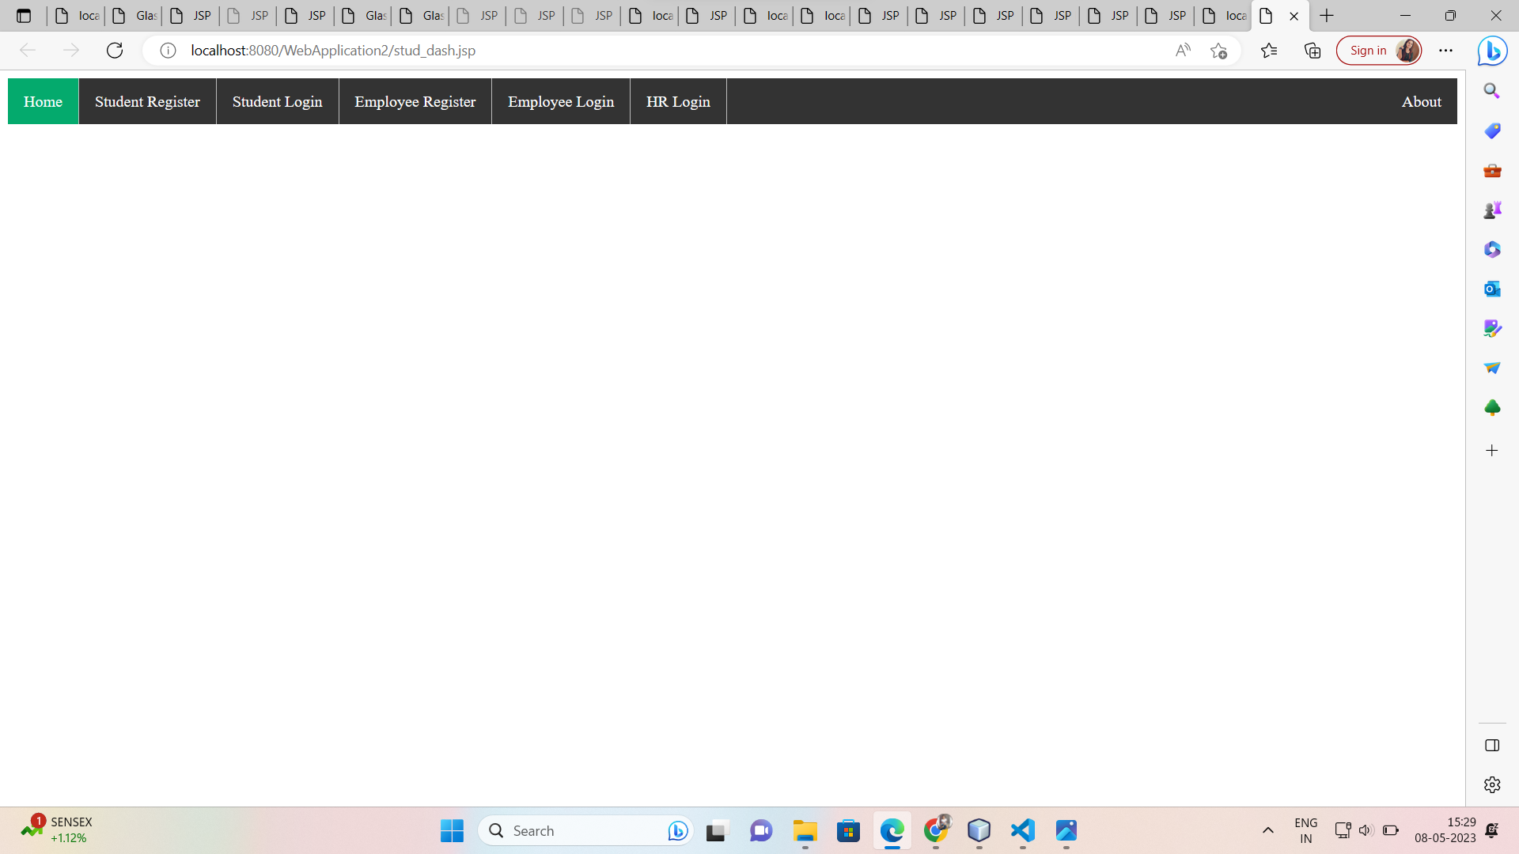

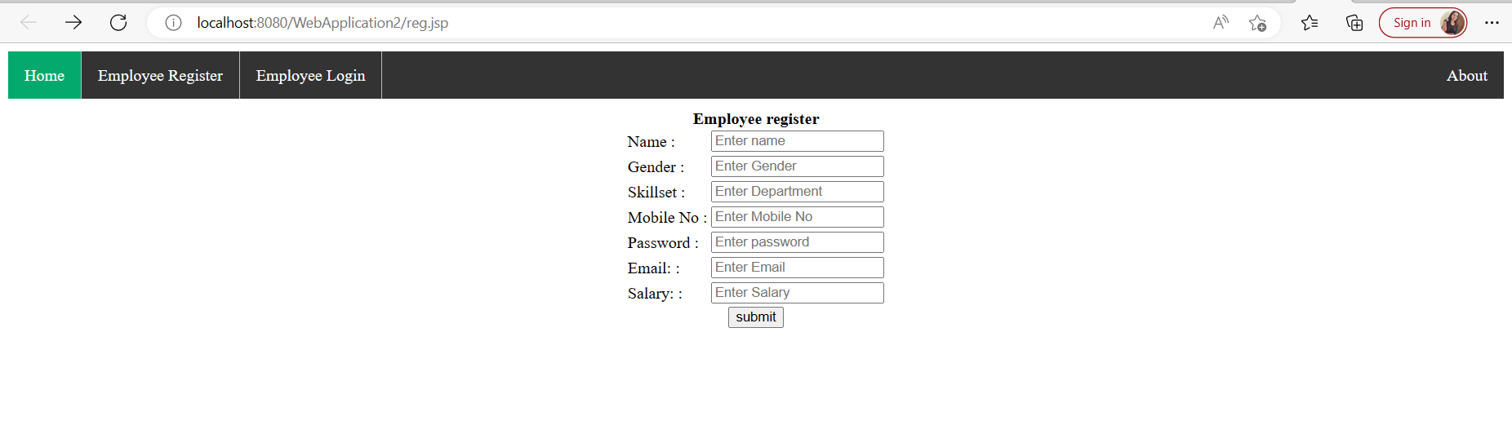

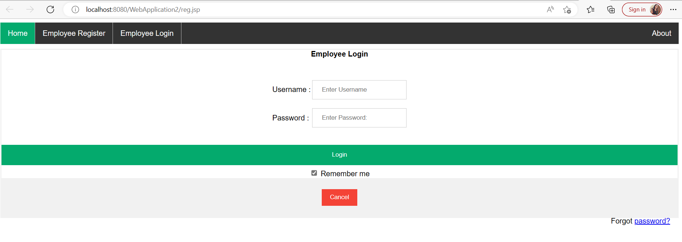

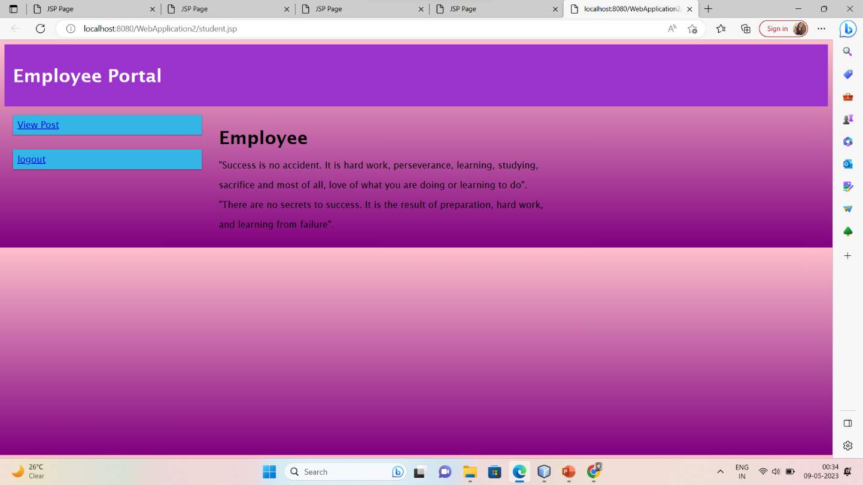

# Chapter 6: Result and Learning from Internship

### Findings:

1. Insert a image within a web page.
2. Create a link within a web page.
3. Create a table within a web page.
4. Insert heading levels within a web page.
5. Insert ordered and unordered lists within a web page.
6. Use cascading style sheets.
7. Create a web page.
8. Validate a web page.

### Conclusion:

By using the defined technologies, we have created a website right now. We are developing some more WebPages, and now working on adding further services such as Downloading and online reading. In the end, we want to conclude that practical training is of great importance as it gives the exposure and an opportunity of presenting a seminar before the audience. It develops a sense of responsibility and a feeling of togetherness of working together thereby developing a team spirit for the successful completion of the project. It is an important opportunity which provides the working environment of an organization as to how to deal with the professionals and the customers which plays an important role in building customer satisfaction. A web-based HR management system can be a game-changer for organizations, providing them with the ability to manage their human resource functions more effectively and efficiently. With the use of advanced technologies, companies can automate routine HR tasks, streamline processes, and gain real-time insights into employee data, which can help them to make better decisions, improve employee engagement, and enhance overall organizational performance.The market for web-based HR systems is growing rapidly, and the demand for more advanced and sophisticated systems is increasing as more companies adopt these systems. Furthermore, the use of cloud-based technologies can provide better security and data privacy compared to traditional HR systems.

### Learning From Industry:

**How to put my knowledge and skills into practice?**

From conducting comprehensive competitor analysis research, to designing a marketing and communication plan, my knowledge of business and marketing theories was transformed into a series of practical techniques and skills that I can now implement in real-life business scenarios, all thanks to my internship.

### The benefits of networking?

During my internship, I learned how to communicate and build relationships with the people I worked with. I learned how to introduce myself, talk about my interests, knowledge and skills with entrepreneurs and business owners, as well as how to ask questions and gain a better understanding of businesses not only in the co-working space, but also others in the market. This process overall helped me develop my professional network and emphasized the importance of creating these connections. I also connected with most of them via LinkedIn, which is obviously a great networking platform for professionals.

### Understanding workplace culture?

Culture influences communication, and as an international student, I learned that every company or organization has its own culture. It’s essential to observe others and learn how they engage and interact with co-workers, or help them with projects and tasks. I quickly learned that whenever something is unclear for me, or I don’t understand, it’s fine to ask for clarification.

### Enthusiasm is invaluable?

As an intern, I discovered it’s essential to be enthusiastic and open to learning new skills, asking for more work and being curious to learn and ask questions. This attitude will show that you enjoy being part of the team and that you're keen to help. Having curiosity and enthusiasm also means that, as an intern, you get a lot out of what you’re doing, which opens lots of opportunities.

### Keeping a journal is great for personal growth?

During my internship, I had a journal and took notes every day about new things I learned, feedback I was given by my manager, strengths and weaknesses I noticed, and things I wanted to research and learn more about. This helped me understand myself more and identify the areas that I needed to improve in.

### How important is good communication?

Communication is the key to success in a professional environment. I learned that it’s important to communicate with my manager via phone, email or SMS if I have questions or if I don’t know how to work on a task. Asking for help and clarification is better than pretending you’ve understood what you need to do, no matter what. However, I also found that if you can Google something, then do. Avoiding asking questions if you can find answers elsewhere is part of being a good communicator – keep in mind that everyone’s time is valuable. As an intern, good communication will help with productivity, efficiency, engagement and growth.

# Chapter 7: BIBLIOGRAPHY

1. https://www.w3schools.in/jsp/tutorials/
2. <https://www.w3schools.com/html/>
3. https://www.w3schools.com/css/default.asp
4. https://freefrontend.com/css-animated-backgrounds/
5. https://www.w3schools.com/java/